Multihop localization:
- Compute distance between node pairs
- Topological information from anchor node infers a hop count threshold
- Trilateration or an improved Black-winged Kite optimization algorithm is employed to localize

Background of Multi-hop Localization:
Links between localization system and devices can be blocked by obstacles and not all devices are equipped with GPS.

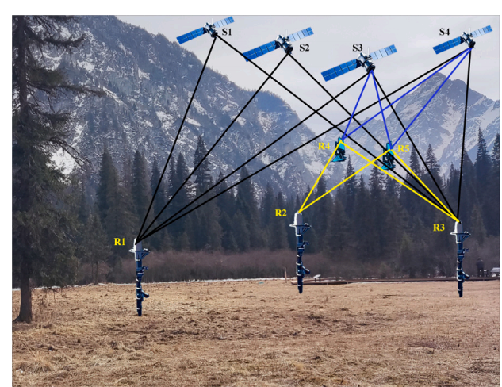
R1,R2 and R3 are directly linked to S1, S2, S3 and S4.
R4, R5 can only connected with S3, S4, R2 and R3. R2 and R3 are anchor nodes

Distance Measurement:
- Range-based: RSSI-based,ToA based, UWB-based
- Range-free(widely used): DV-Hop(Distance Vector Hop), APIT and Amorphous

Range-based: Signal generator, mapping between Inter-node signal and corresponding distance by using distance-signal model.

Range-free: use connectivity information between nodes.

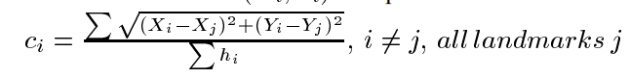
- Compute correction between landmarks

